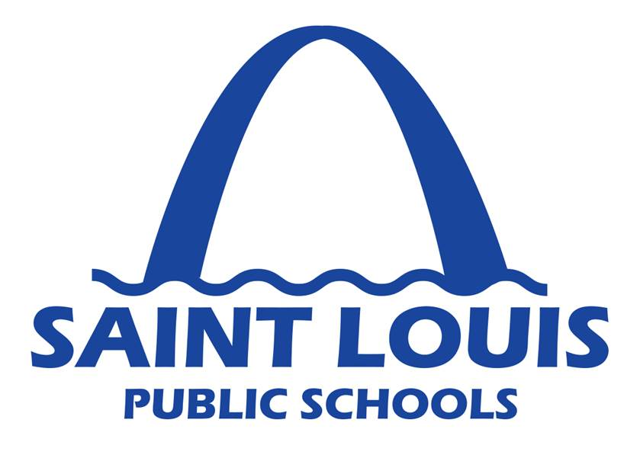
Frequently Asked Questions – Water Testing
August 19, 2016

Q: Does my child’s school have lead in the drinking water?

A: An independent hazardous materials consultant has tested all drinking fountains and sinks at all school buildings. Based on preliminary data, there were 82 sinks or fountains in the District with an elevated lead level. Those sinks and fountains have been turned off and are not accessible to students or staff. If your child’s school has a sink or fountain with an elevated lead level, you should have received a letter from the principal on the first day of school. The list of schools with elevated lead levels is available at www.slps.org/water.

Q: How is my child getting clean drinking water if the school’s water fountains are shut off because of lead?

A: All schools have multiple drinking fountains available for students and staff to access clean drinking water. However, if it is determined that a school needs additional drinking water, the District is providing bottled water for students and staff.

Q: What is the District doing about the lead in the water?

A: Any drinking fountain or sink that has an elevated lead level is immediately turned off and tagged as “out of order” to prevent students or staff from consuming the water. The District will repair or replace the fountain or sink to remediate the lead levels. Next, the fountain or sink will be re-tested to ensure there are no elevated lead levels before the fountain or sink is turned back on.

Q: How long will it take for the District to fix the fountains or sinks that have lead in the water?

A: Corrective measures to remediate or replace each drinking fountain and sink are taking place as quickly as possible. In some cases, parts must be ordered and may delay immediate corrective action. However, all schools will have adequate sources of consumable water at all times.

Q: How did the District conduct the tests?

A: The testing of SLPS water fountains and sinks was conducted under the strictest conditions to ensure our water sources are as safe as possible for students and staff. While corrective action is required for any level exceeding 20 parts per billion, the District has established a more stringent threshold of 10 parts per billion to address any potential future water issues.

To date, the District’s consultants tested water fountains and sinks at 74 school buildings. A total of 744 water sources were tested. Based on preliminary data, a total of 82 sources have a lead level in excess of 10 parts per billion. Those 82 samples were attributed to 30 different buildings. Of those 30 buildings, 12 are providing bottled water to students and staff due to the location of a closed fountain or the limited number of working drinking fountains available in that building.

Q: Where can I go to have my child tested for lead?

A: The St. Louis City Health Department offers free lead testing for children under the age of 6 and pregnant women. For more information, please call (314) 657-1487. Parents may also contact their child’s health care provider to ask about taking a lead test.

Q: Why is the District testing the water for lead?

A: Student and staff safety remain among the highest priorities for the District. Testing the water for lead is a natural next step in the District’s commitment

Q: Is there a list of all schools that have an elevated lead level in the water?

A: Based on preliminary date, the following schools had at least one test sample indicate a lead level in excess of 10 parts per billion:

AESM Middle School
Beaumont High School
Busch Middle School
Carr Lane Middle School
Carver Elementary School
Clay Elementary School
Clyde C. Miller High School
Compton-Drew Middle School
Cote Brilliante Elementary School
Fanning Middle School
Galludet
Gateway STEM High School
Gateway Middle School
Herzog Elementary School
Hickey Elementary School
Laclede Elementary School
Langston Middle School
Long Middle School
Mann Elementary School
Meramec Elementary School
Nahed Chapman New American Academy
Northwest Law Academy High School
Oak Hill Elementary School
Patrick Henry Downtown Academy
Peabody Elementary
Roosevelt High School
Shenandoah Elementary School
Sigel Elementary School
Sumner High School
Vashon High School

Q: When will the District have final results about the water testing?

A: Final test results are expected to be received by the District on August 25th.

